Detecting Web Attacks with End-to-End Deep Learning

To run web code double click on ‘run.bat’ file to start python DJANGO server and will get below screen

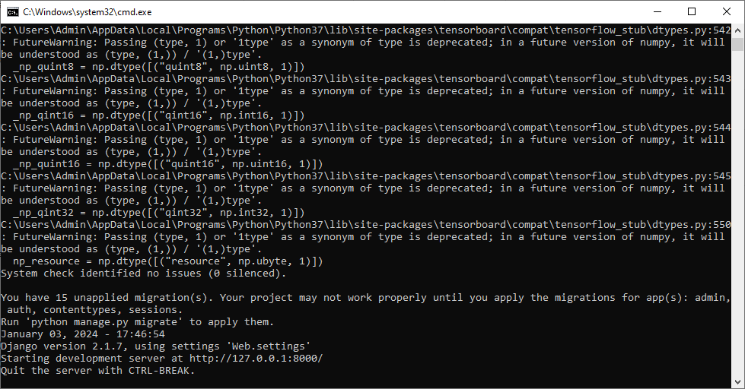

In above screen python web server started and now open browser and enter URL as <http://127.0.0.1:8000/index.html> and press enter key to get below page



In above screen click on ‘New User Register Here’ link to get below user signup screen

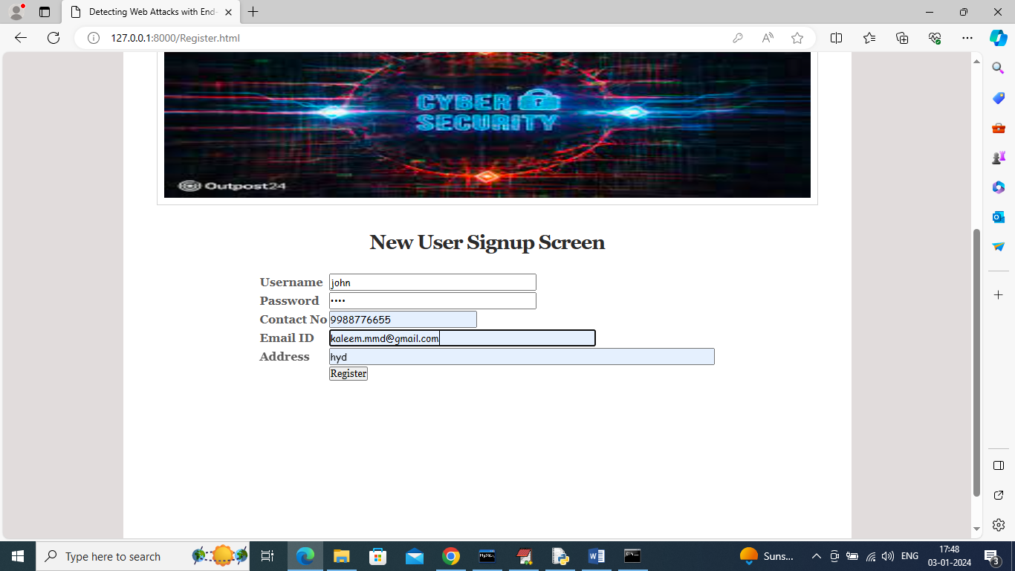

In above screen user is entering sign up details and give valid EMAIL ID to get OTP password and then press button to complete sign up and get below page



In above screen user signup completed and now click on ‘User Login’ link to get below page

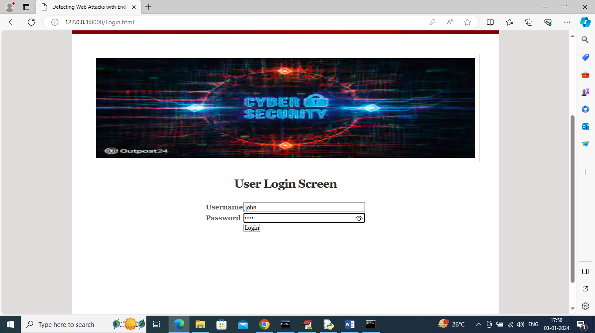

In above screen user is login and after login will get below OTP page

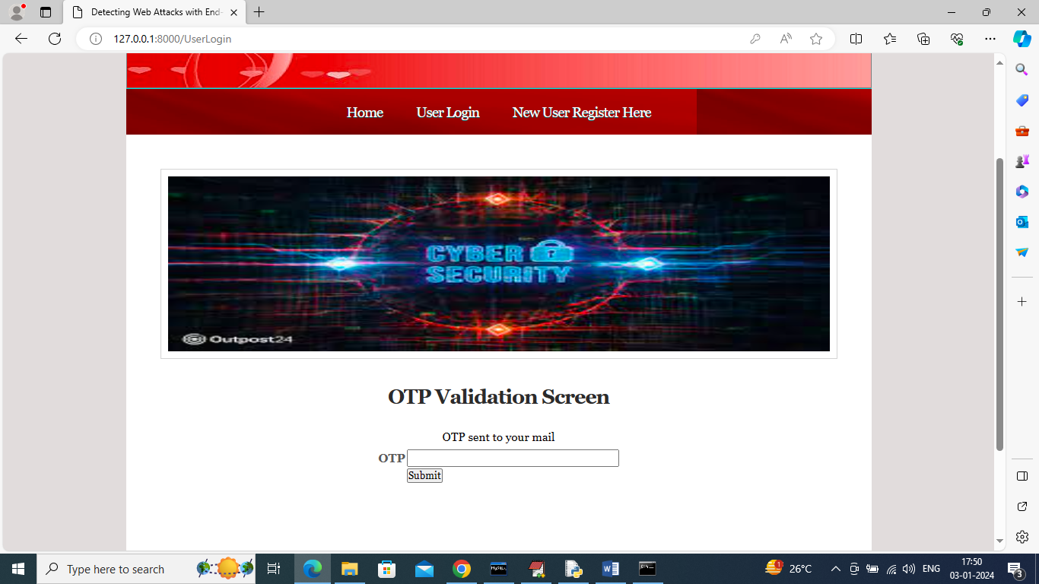

Above OTP we can receive in given email at sign up time

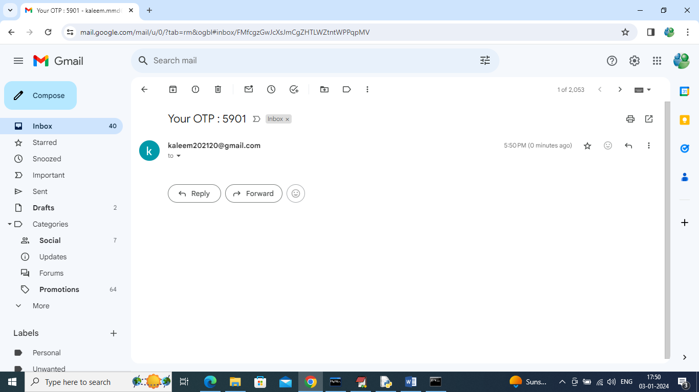

In above screen 5901 is the OTP which has to enter in OTP validation page like below screen

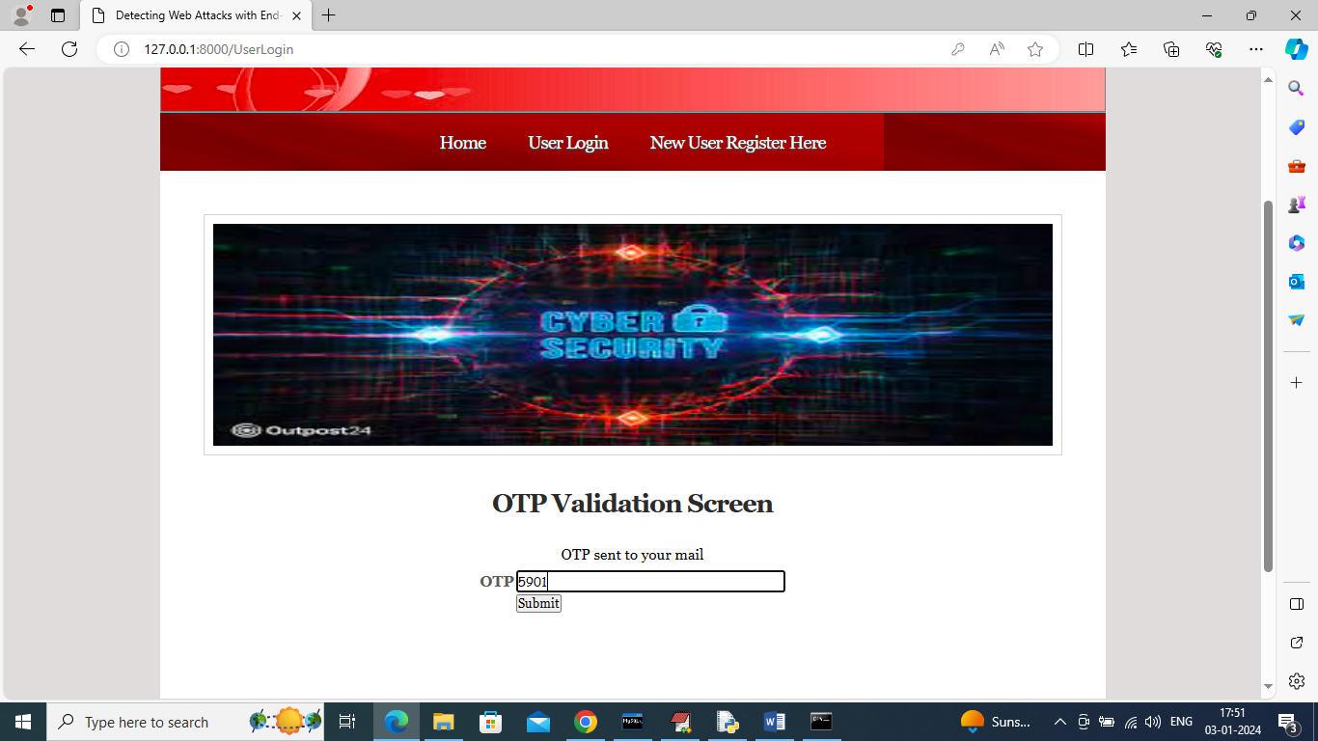

In above screen after entering OTP then press button to get below page



In above screen click on ‘Upload Dataset’ link to get below page

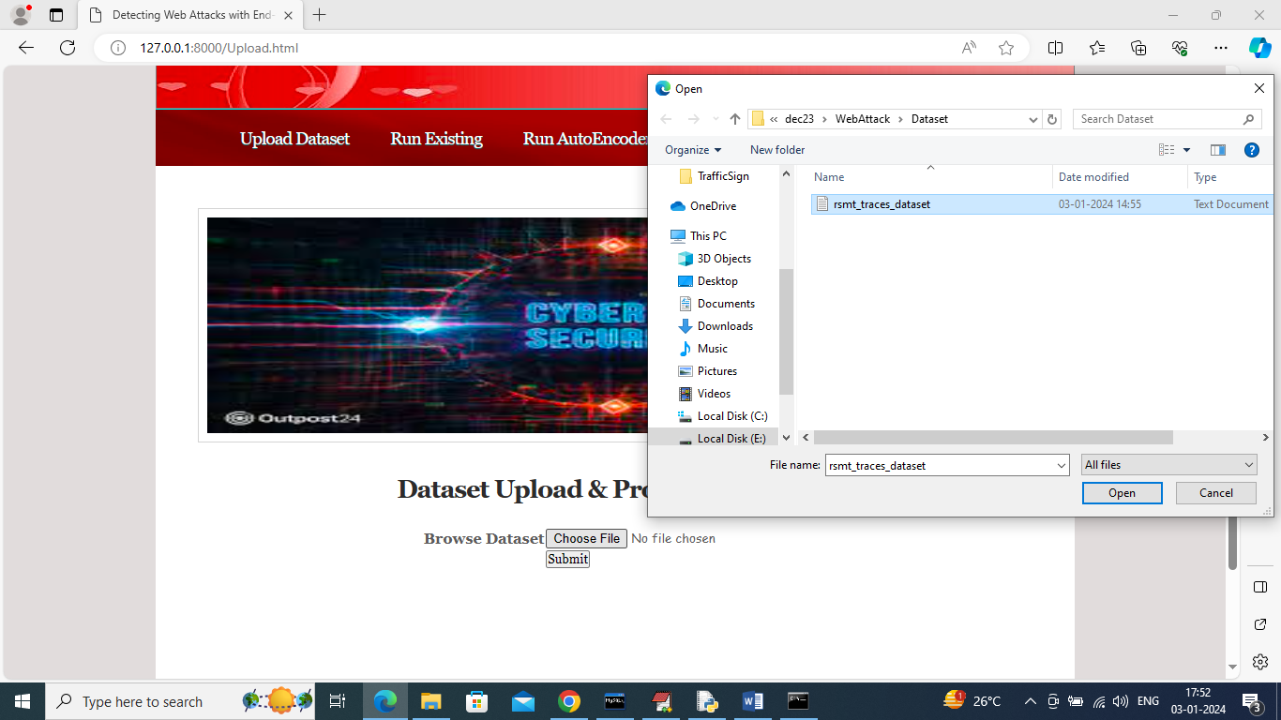

In above screen select and upload dataset and then click on “open” and “Submit’ button to load and process dataset and then will get below page

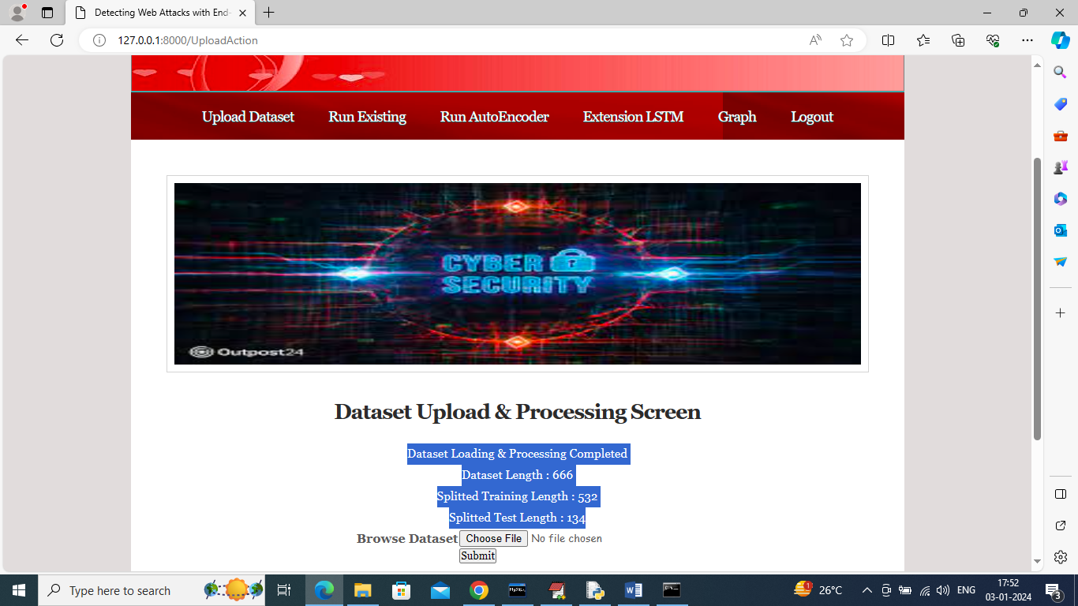

In above screen can see dataset loaded and processed and now click on ‘Run Existing’ link to run existing algorithms and then will get below output

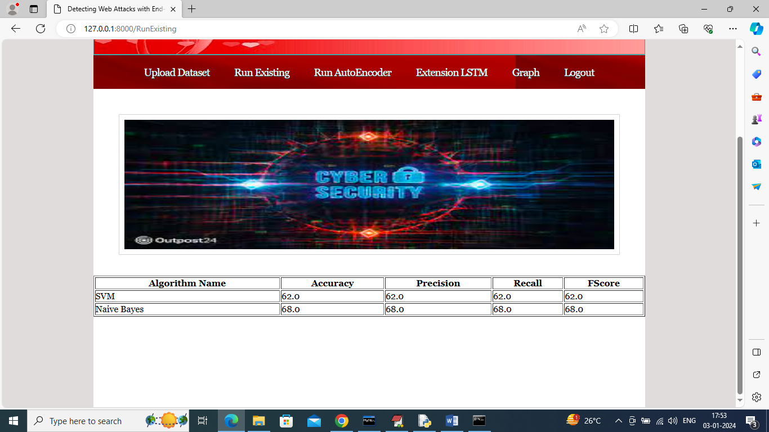

In above screen existing SVM and Naïve Bayes training completed and can see SVM got 62% and Naïve Bayes got 68% accuracy and can see other metrics also and now click on ‘Run Auto Encoder’ link to run propose algorithm and then will get below page

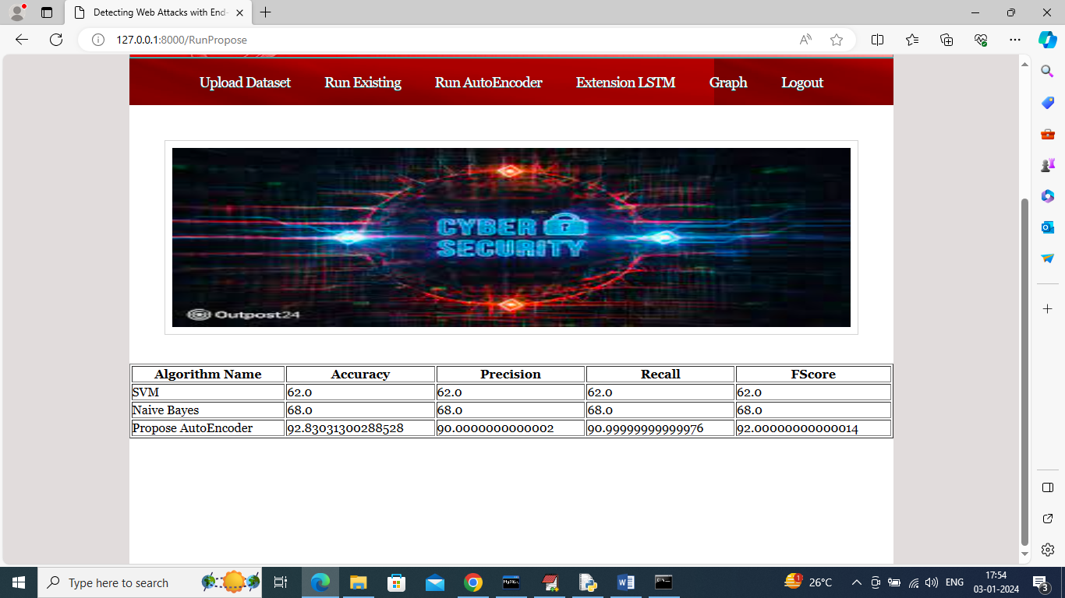

In above screen can see existing and propose algorithm performance and now click on ‘Run Extension LSTM’ algorithm link to get below page

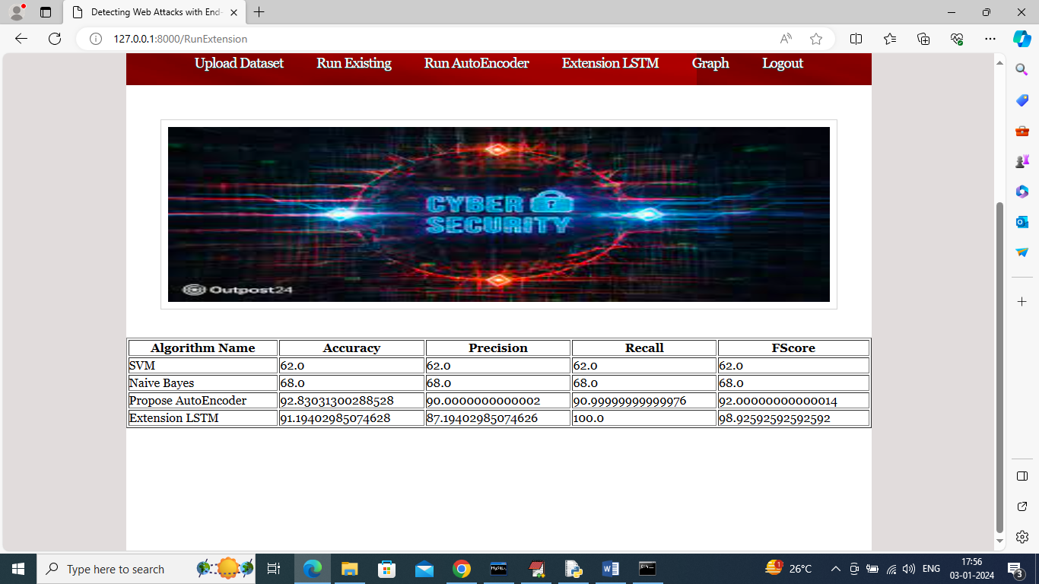

In above screen extension LSTM got 100% recall which is higher than existing and propose algorithms and now click on ‘Graph’ link to get below comparison graph

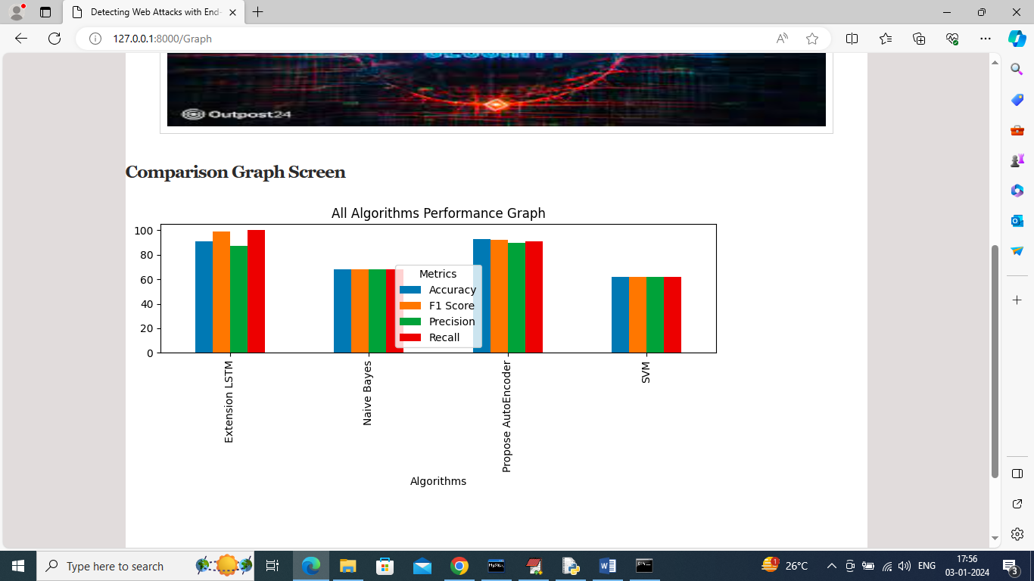

In above graph x-axis represents algorithm names and y-axis represents accuracy and other metrics in different colour bars and in all algorithm extension got high recall.